

Alandi (D), Pune Affiliated to

Savitribai Phule Pune University

A PROJECT REPORT
ON

“AI-BASED INTERVIEW EVALUATION SYSTEM”

BY

Ankita Sachin Gaykar(TYI1171)

Under the guidance of
Prof. Rajshree Satpute

In Partial fulfilment of
T.Y.B.Sc(CS)
Academic Year 2025-26



School of Computer Science and Application

CERTIFICATE

Exam Seat
This is to certify that, the project report entitled “AI-BASED INTERVIEW EVALUATION SYSTEM’’ which is submitted by Ankita Sachin Gayakr(TI1171) Division I1 students of MAEER’s MIT Arts, Commerce and Science College, Alandi(D), Pune-412105 in partial
fulfilment of T.Y.B.Sc. (Computer Science) Project Work in academic year 2025-26. They have satisfactorily completed the project work under our guidance and supervision. We wish our best wishes for your future endeavour.

Prof.Rajshree Satpute | Dr. Sangeeta Borde
Project Guide | HOD (Sci and Comp. Sci)
Internal Examiner | External Examiner

INDEX

Sr. No. | Chapter | Page No
1 | INTRODUCTION
 | 1.1 Introduction | 5
 | 1.2 Problem statement | 6
 | 1.3 Objectives and goals | 7
 | 1.4 Scope of the System | 7
 | 1.5 Existing System and Need of the System | 8
2 | PROPOSED SYSTEM
 | 2.1 Proposed System | 9
 | 2.2 Advantages and Disadvantages | 9
 | 2.3 Feasibility Study | 10-11
 | 2.4 System Requirements (software and Hardware  Specification) | 11
3 | DATA DICITIONARY AND RELATIONAL DATABASE DIAGRAM | 12-14
4 | SYSTEM MODELING
 | 4.1 ER Diagram | 15
 | 4.2 Class Diagram | 16
 | 4.3 Use Case Diagram | 17
 | 4.4 Activity Diagram | 18
 | 4.5 Sequence Diagram | 19
5 | OUTPUT SCREENS | 20-23
6 | FUTURE SCOPE | 24
7 | CONCLUSION | 25
8 | BIBLIOGRAPHY (REFERENCES AND  BOOKS AND LINKS) | 26

ACKNOWLEDGEMENT
I take this opportunity to express my sincere gratitude to everyone who has directly or indirectly helped me in completing the project successfully. I owe profound intellectual debt to Prof. Rajshree Satpute who is a guiding source of encouragement and helped me through-out the course of my project. I am also thankful to Director. Dr. B. B. Waphare, Principal MIT Arts Commerce and Science College Alandi(D), Pune-412105 and also to Dr. Sangeeta Borde, HOD, Science and Comp. Science for providing me with this opportunity.

Ankita Sachin Gaykar
TYBSC(CS)-I1

1.INTRODUCTION

1.1 Introduction

The recruitment process is one of the most critical functions of any organization, as selecting the right candidate directly impacts productivity and growth. Traditionally, interviews are conducted manually by human recruiters, which often involves significant time, effort, and resources. Moreover, manual interview processes are prone to several limitations such as human bias, inconsistency in evaluation, and difficulty in assessing a candidate’s complete skill set objectively. With the rapid advancement of technology, especially in the field of Artificial Intelligence (AI), there is a growing need to modernize and automate the interview evaluation process.

The AI Based Interview Evaluation System is a web-based application designed to address these challenges by leveraging AI technologies to conduct and evaluate interviews efficiently. This system enables candidates to participate in interviews through multiple modes such as text, voice, and video, making the process flexible and accessible. Unlike traditional methods, this system uses intelligent algorithms to analyze candidate responses, communication skills, and facial expressions, ensuring a more comprehensive and unbiased evaluation.

The core functionality of the system is powered by advanced AI techniques, including Natural Language Processing (NLP) for analyzing textual responses, speech recognition for converting spoken answers into text, and computer vision for detecting facial emotions during video interviews. These technologies work together to assess not only the correctness of answers but also the candidate’s confidence, communication ability, and emotional state during the interview. As a result, the system provides a holistic evaluation of candidates.

Another significant advantage of this system is its ability to generate automated and detailed interview reports. These reports offer insights into candidate performance, including strengths, weaknesses, and overall suitability for a role. This helps recruiters make informed decisions quickly and efficiently. Additionally, by minimizing human intervention, the system reduces the chances of bias and ensures fairness and transparency in the selection process.

The project follows the Software Development Life Cycle (SDLC) Waterfall Model, which provides a structured and systematic approach to development. Each phase, from requirement analysis to maintenance, is clearly defined, ensuring a smooth and organized workflow suitable for academic project implementation.
The system is developed using modern web technologies such as HTML, CSS, and JavaScript for the frontend, while Python with the Flask framework is used for backend development. AI modules are integrated using libraries like NLTK, SpaCy, OpenCV, and SpeechRecognition. The database is managed using SQLite during development and MySQL in production, ensuring efficient data handling and scalability.

In conclusion, the AI Based Interview Evaluation System aims to revolutionize the traditional hiring process by introducing automation, intelligence, and fairness. It not only saves time and resources but also enhances the accuracy and reliability of candidate evaluation, making it a valuable solution for modern recruitment systems.

1.2 Problem statement

In today’s competitive and fast-paced environment, organizations receive a large number of job applications for limited positions. Conducting interviews manually for each candidate is a time-consuming and resource-intensive process. Recruiters are required to schedule interviews, evaluate responses, and make decisions, which often leads to delays in the hiring process. As the number of candidates increases, maintaining consistency and efficiency in evaluation becomes increasingly difficult.

One of the major challenges in traditional interview systems is human bias. Interviewers may consciously or unconsciously favor or reject candidates based on personal preferences, mood, or subjective judgment rather than objective evaluation criteria. This can lead to unfair hiring decisions and may prevent deserving candidates from being selected. Additionally, different interviewers may use different standards for evaluation, resulting in inconsistent assessment across candidates.

Another limitation is the lack of comprehensive evaluation. Manual interviews often focus primarily on verbal responses, while other important aspects such as communication skills, confidence level, tone of speech, and facial expressions are not systematically analyzed or recorded. As a result, the evaluation process may overlook critical factors that contribute to a candidate’s overall suitability for a role.
Furthermore, traditional interviews are not easily scalable. Conducting interviews for a large number of candidates requires significant human effort, infrastructure, and time. This becomes particularly challenging for organizations conducting mass recruitment or remote hiring. The absence of automation also limits the ability to generate detailed and data-driven reports for better decision-making.

In addition, there is a lack of transparency and documentation in manual interview processes. Feedback is often not properly recorded or analyzed, making it difficult to justify selection or rejection decisions. Candidates also do not receive structured feedback, which limits their ability to improve.

With the advancement of Artificial Intelligence, there is an opportunity to overcome these limitations by developing an automated system that can evaluate candidates fairly, consistently, and efficiently. Such a system should be capable of analyzing candidate responses through text, voice, and video, while also assessing communication skills and emotional expressions. It should provide accurate, unbiased, and transparent evaluation results along with detailed performance reports.

Therefore, there is a strong need for an AI-based Interview Evaluation System that can automate the interview process, reduce human bias, improve evaluation accuracy, and provide scalable and efficient recruitment solutions.

1.3 Objectives and goals

The primary aim of the AI Based Interview Evaluation System is to enhance and modernize the traditional recruitment process by integrating Artificial Intelligence. The system is designed to ensure fair, efficient, and accurate evaluation of candidates while minimizing manual effort and bias.

Objectives:

- To Automate the Interview Process
The system aims to replace manual interview procedures with an automated platform where candidates can attend interviews without direct human involvement. This reduces the workload on recruiters and speeds up the hiring process.

- To Reduce Human Bias
One of the key objectives is to eliminate subjective judgment in candidate evaluation. By using AI algorithms, the system ensures that all candidates are assessed based on the same criteria, promoting fairness and equality.

- To Analyze Candidate Responses Using NLP
The system uses Natural Language Processing (NLP) techniques to evaluate candidate answers. It checks for relevance, correctness, keyword matching, and overall quality of responses, providing a more objective assessment.

- To Evaluate Communication Skills
Through speech recognition and audio analysis, the system assesses pronunciation, clarity, fluency, and confidence in a candidate’s speech.

- To Detect Facial Expressions and Emotions
Using computer vision techniques, the system analyzes facial expressions during video interviews to understand emotions such as confidence, nervousness, or hesitation, contributing to a holistic evaluation.

Goals:

- To Build an Intelligent Recruitment System
Develop a smart platform that integrates multiple AI technologies (NLP, speech processing, and emotion detection) for comprehensive candidate evaluation.
- To Ensure Transparency in Evaluation
Provide clear, data-driven results and reports that justify candidate selection or rejection, increasing trust in the system.
- To Improve Hiring Quality
Enable organizations to select the most suitable candidates based on accurate and consistent evaluation metrics.
- To Save Time and Resources
Minimize the need for manual intervention, reduce interview duration, and optimize recruiter efforts.
- To Support Remote and Flexible Interviews
Allow candidates to attend interviews from any location using text, voice, or video, making the system more accessible.

1.4 Scope of the System

The system automates the interview process using AI by evaluating candidates through text, voice, and video analysis. It provides fair and consistent results with automated report generation. The system is suitable for small to medium-scale recruitment and can be enhanced further in the future.

1.5 Existing System and Need of the System

- Existing System:

1. Manual Interview System:
- Interviews are conducted face-to-face by recruiters or panel members.
- Candidate evaluation is based on human judgment, which may vary from person to person.
- The process is time-consuming as each candidate must be interviewed individually.
- High chances of bias, inconsistency, and errors in evaluation.
- Feedback is often not properly recorded or documented for future reference.

2. Basic Digital Tools (Standalone Platforms):
- Some organizations use online forms or simple platforms for conducting initial screening tests.
- Video conferencing tools (e.g., Zoom/Meet) are used, but evaluation is still done manually.
- No automated analysis of candidate responses, communication, or behavior.
- Limited integration between different tools, leading to inefficiency.

3. Online Interview Platforms:
- Platforms provide features like online tests, coding rounds, or recorded video interviews.
- Evaluation is partially digital but still depends on human recruiters for final decisions.
- Lack of advanced AI features like emotion detection, speech analysis, and intelligent scoring.
- Limited ability to provide detailed, automated, and unbiased reports.

2.Need of the System:

1. Automate and Streamline Interview Process
- Reduce manual effort by conducting interviews through an automated system.
- Automatically evaluate candidate responses and generate performance reports.

2. Reduce Human Bias
- Ensure fair and consistent evaluation using AI-based algorithms.
- Eliminate subjective decision-making in candidate selection.

3. Comprehensive Candidate Analysis
- Analyze answers using NLP for accuracy and relevance.
- Evaluate communication skills through speech analysis.
- Detect facial expressions and emotions using video processing.

4. Improve Efficiency and Save Time
- Conduct multiple interviews simultaneously without human intervention.
- Reduce hiring time and speed up the recruitment process.

5. Centralized Data Management
- Store candidate details, interview data, and reports in a single system.
- Enable easy access, tracking, and analysis of candidate performance.

6. Enhance Transparency and Reporting
- Provide detailed and accurate evaluation reports.
- Help recruiters make data-driven and informed decisions.

2.1 PROPOSED SYSTEM

The proposed system is an AI Based Interview Evaluation System designed to automate and enhance the traditional interview process using advanced Artificial Intelligence techniques. This system provides a smart platform where candidates can attend interviews through text, voice, and video, and their performance is evaluated automatically without human intervention.

1.Automated Interview Process
The system conducts interviews automatically by presenting questions to candidates and recording their responses without the need for a human interviewer.

2.Multi-Mode Interview Support
Candidates can answer questions through text, voice, or video, making the system flexible and user-friendly.

3.AI-Based Evaluation
- NLP is used to analyze the relevance and quality of answers.
- Speech analysis evaluates communication skills like fluency and clarity.
- Facial emotion detection identifies confidence, stress, or hesitation.

4.Real-Time Analysis and Scoring
The system processes responses instantly and assigns scores based on predefined criteria.

5.Automated Report Generation
Detailed reports are generated for each candidate, including performance scores, strengths, and areas for improvement.

6.Centralized Data Management
All candidate data, interview responses, and reports are stored securely in a centralized database for easy access and management.

7.User-Friendly Interface The system provides an intuitive interface for both candidates.

2.2 ADVANTAGES & DISADVANTAGES OF THE SYSTEM

Advantages:

- Reduces human bias
- Saves time and effort
- Consistent evaluation
- Multi-mode interview support (text, voice, video)
- Comprehensive analysis (NLP, speech, emotion detection)
- Automated report generation
- Remote accessibility
- Centralized data management

Disadvantages:

- Dependence on technology
- Limited human judgment
- Accuracy limitations of AI
- Technical issues

2.3 FEASIBILITY STUDY

1. Technical Feasibility
- The system can be developed using existing technologies like Python, Flask, HTML, CSS, and JavaScript.
- AI libraries such as NLP, speech recognition, and OpenCV are readily available.
- The required hardware (computer, webcam, microphone) is easily accessible.

2. Economic Feasibility
- Development cost is low as most tools and libraries are open-source.
- Reduces long-term costs by minimizing manual recruitment efforts.
- Saves time and resources for organizations.

3. Operational Feasibility
- The system is user-friendly and easy to operate for both candidates and administrators.
- Reduces manual workload and improves efficiency in the recruitment process.
- Requires minimal training for users.

4. Legal Feasibility
- The system must ensure data privacy and security of candidate information.
- Should comply with data protection policies and ethical AI usage.

2.4 System Requirements (software and Hardware Specification)

  - Software Requirements:

- Operating System: Windows 10/11, Linux, or macOS
- Frontend Technologies: HTML5, CSS3, JavaScript
- Backend Framework: Database MySql
- Database: SQLite (Development) / MySQL (Production)
- AI/ML Libraries: NLTK / SpaCy (NLP), OpenCV (Face Detection), SpeechRecognition, PyAudio
- IDE/Editor: Visual Studio Code
- Web Browser: Google Chrome

  - Hardware Requirements:

- Processor: Intel i3 or above
- RAM: Minimum 4 GB (8 GB recommended)
- Storage: Minimum 500 MB free space
- Camera: Webcam for video interview and facial analysis
- Microphone: For voice input and speech analysis
- Internet Connection: Stable connection for smooth operation

3.DATA DICITIONARY AND RELATIONAL DATABASE DIAGRAM

  - Data Dictionary

The data dictionary defines the structure of the database used in the AI Based Interview Evaluation System. It includes details about tables, fields, data types, and descriptions.

1.User Table:

Column Name | Data Type | Size | Description | Constraints
user_id | INT | — | Unique ID of user | Primary Key, Auto Increment
Name | VARCHAR | 100 | Name of candidate | Not Null
Email | VARCHAR | 100 | Email address | Unique, Not Null
Password | VARCHAR | 255 | Encrypted password | Not Null
Role | VARCHAR | 20 | User role (Admin/Candidate) | Not Null
created_at | DATETIME | — | Account creation date | Default Current Timestamp

2. Question Table:
Column Name | Data Type | Size | Description | Constraints
question_id | INT | — | Unique question ID | Primary Key, Auto Increment
question_text | TEXT | — | Interview question | Not Null
Category | VARCHAR | 50 | Question category | Not Null
Difficulty | VARCHAR | 20 | Difficulty level | —

  - Interview Table

Column Name | Data Type | Size | Description | Constraints
interview_id | INT | — | Unique interview ID | Primary Key, Auto Increment
user_id | INT | — | Reference to user | Foreign Key
Date | DATETIME | — | Interview date | Not Null
Mode | VARCHAR | 20 | Interview mode (Text/Voice/Video) | Not Null

4.Response Table:
Column Name | Data Type | Size | Description | Constraints
response_id | INT | — | Unique response ID | Primary Key, Auto Increment
interview_id | INT | — | Reference to interview | Foreign Key
question_id | INT | — | Reference to question | Foreign Key
answer_text | TEXT | — | Candidate answer | Not Null
Score | FLOAT | — | AI-generated score | —

5.Report Table:

Column Name | Data Type | Size | Description | Constraints
report_id | INT | — | Unique report ID | Primary Key, Auto Increment
interview_id | INT | — | Reference to interview | Foreign Key, Unique
total_score | FLOAT | — | Total score | Not Null
Feedback | TEXT | — | AI-generated feedback | —
Result | VARCHAR | 20 | Hired/Not Hired result | Not Null

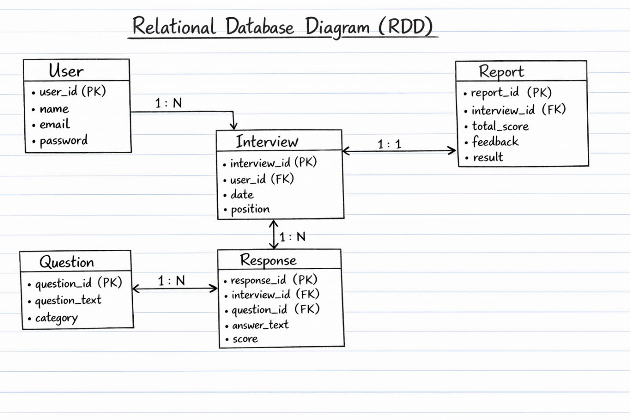

4.SYSTEM MODELING

4.1 ER Diagram

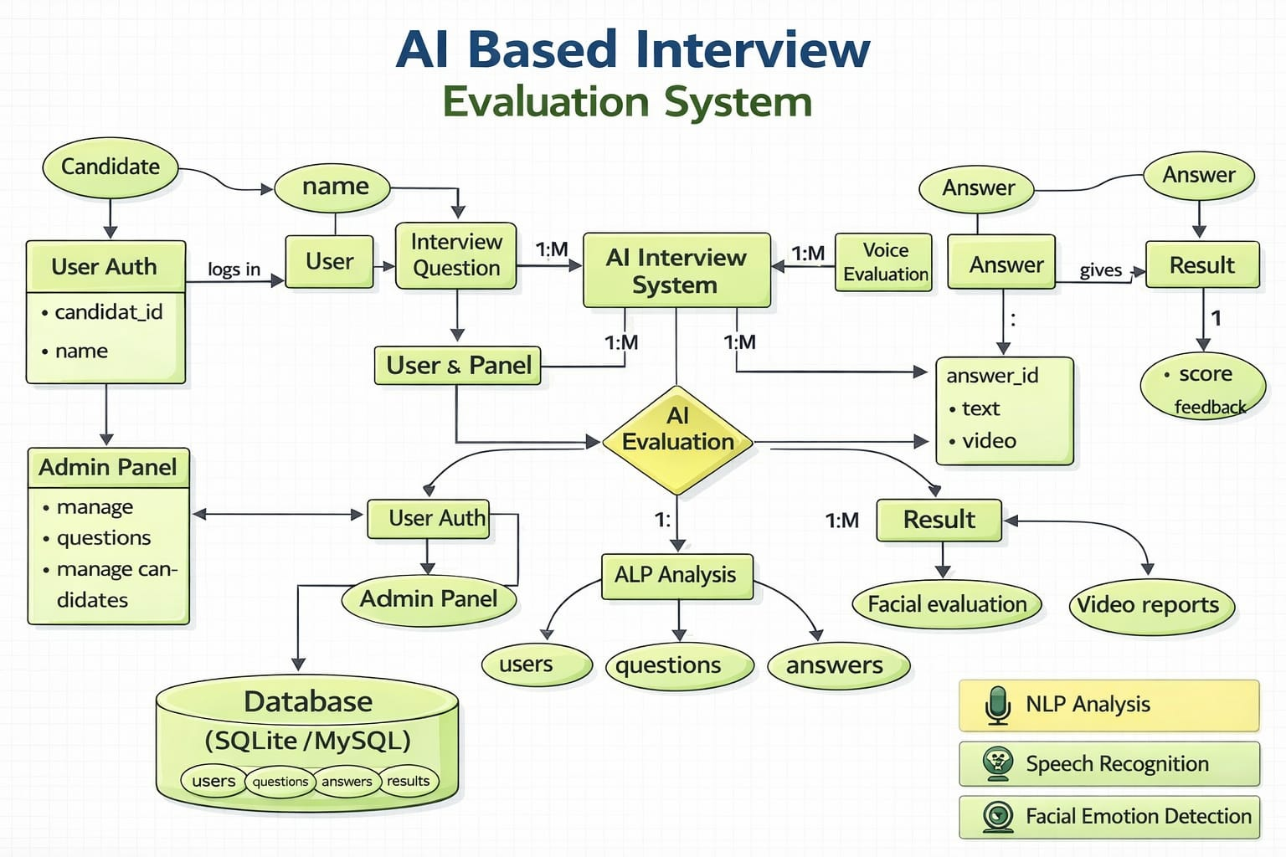
4.2 Class Diagram

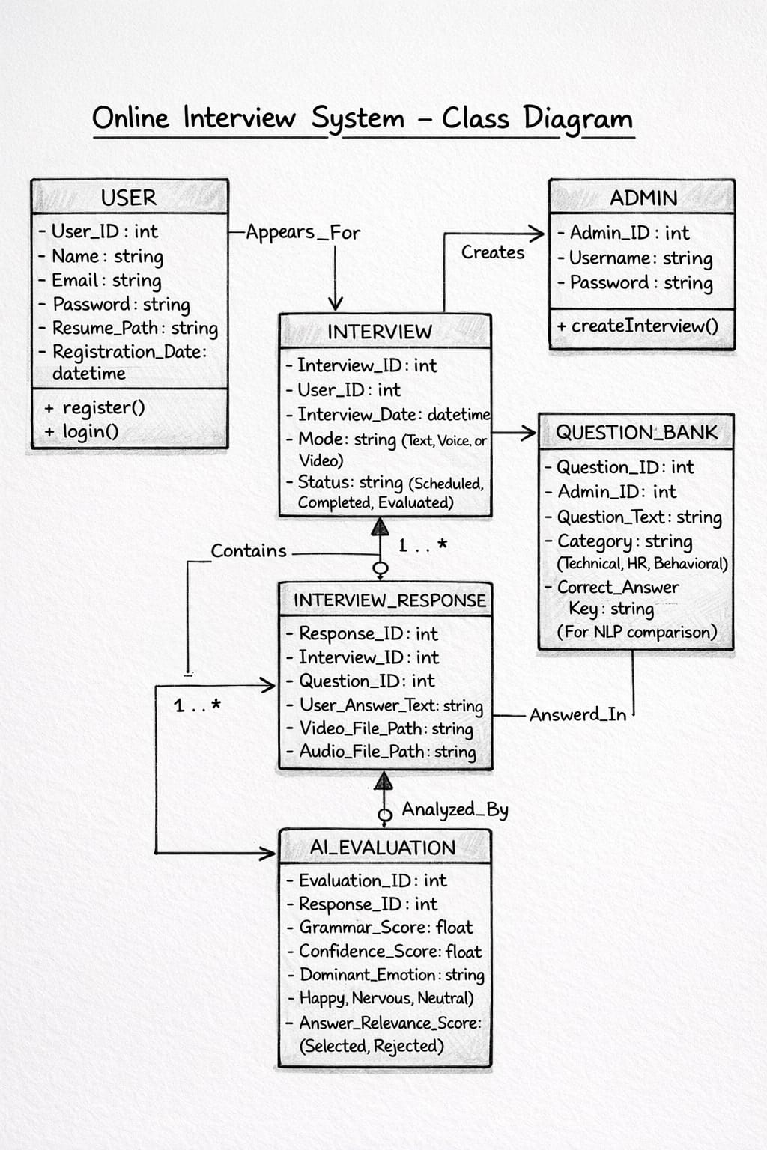
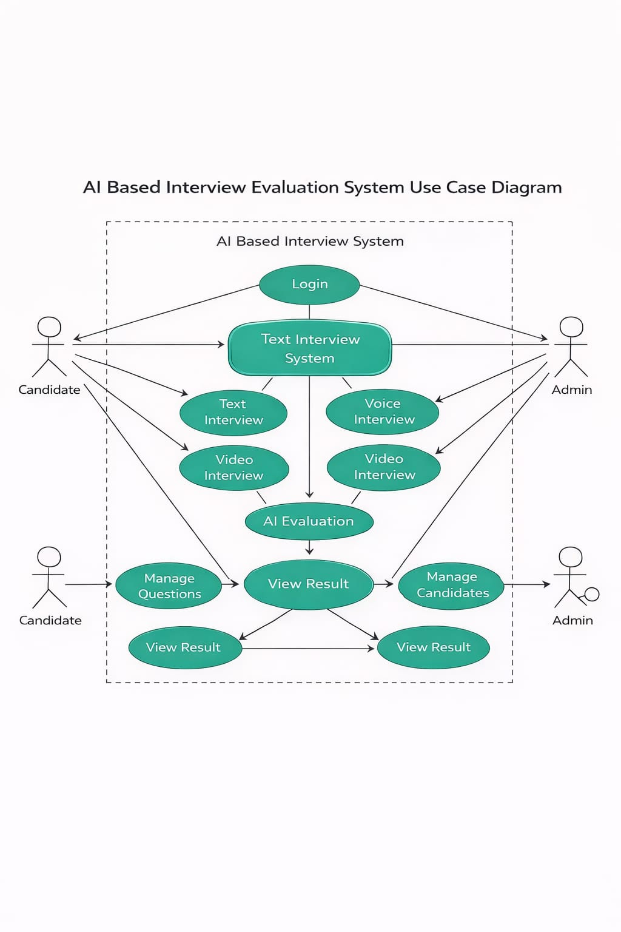
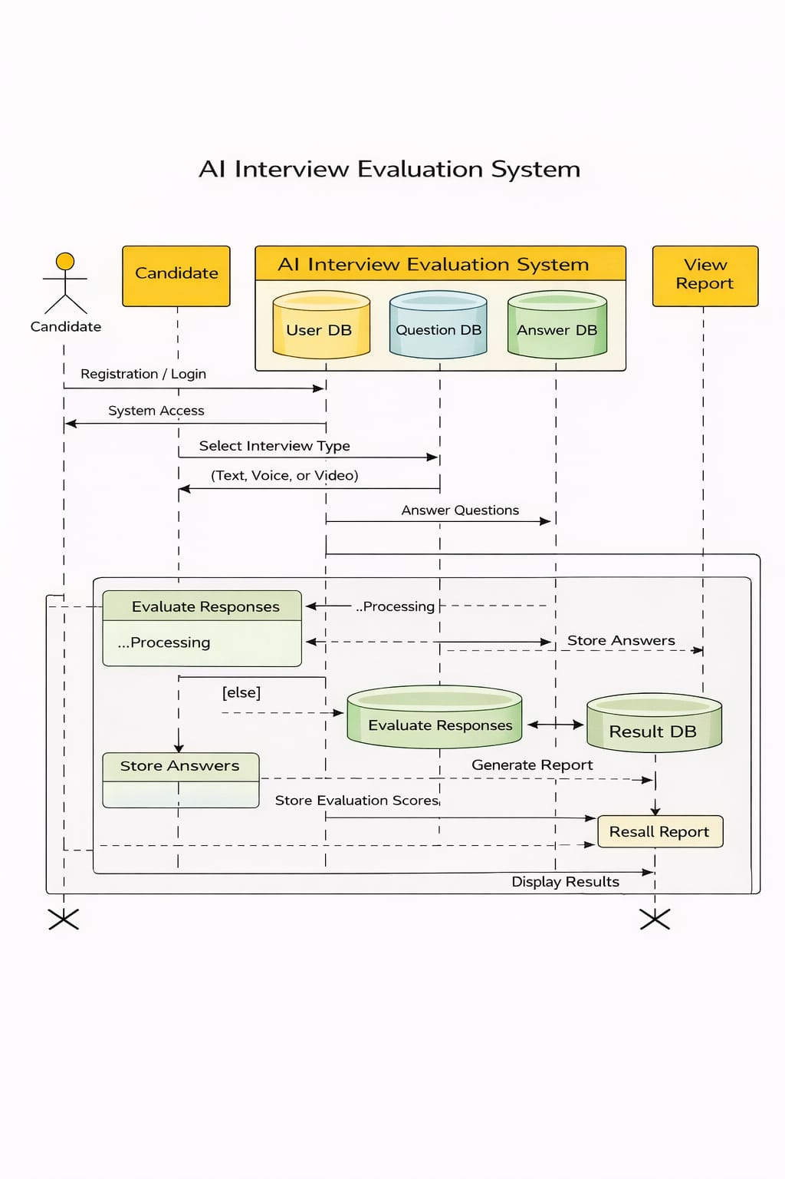
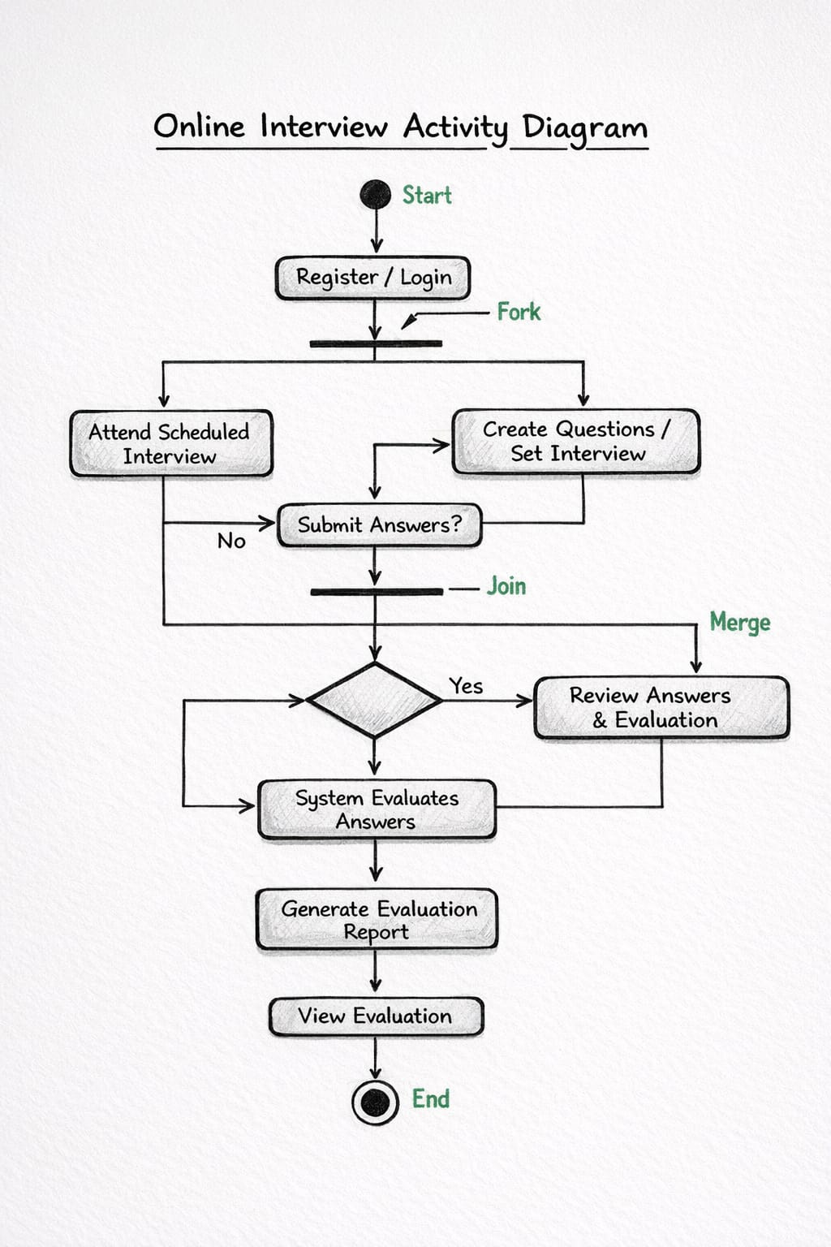

4.OUTPUT SCREENS

1.Home Page:

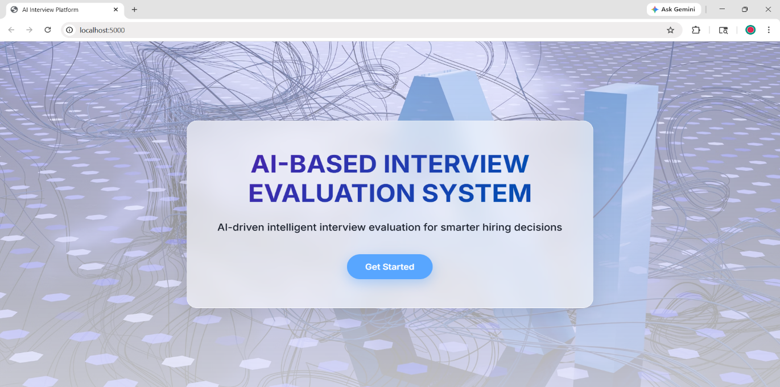

2.Registration Page:
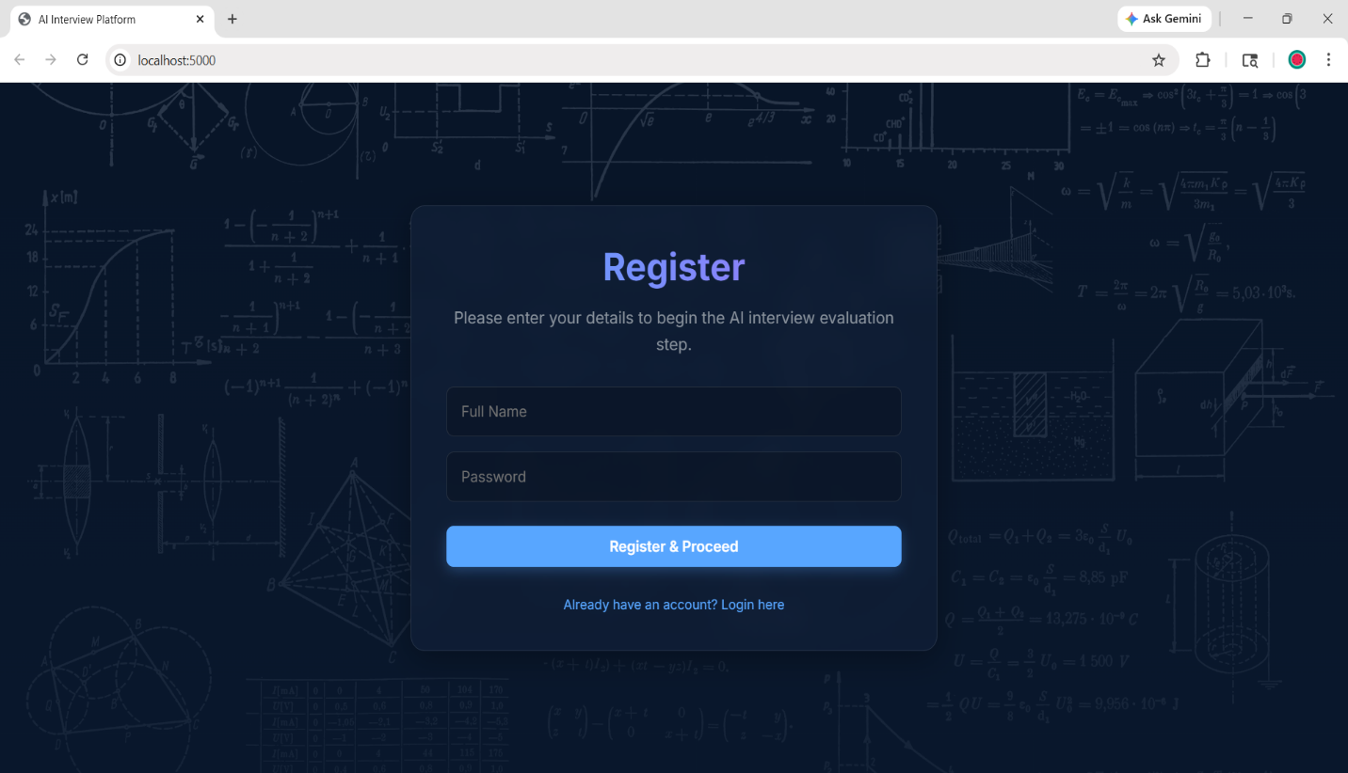
3.Login Page:

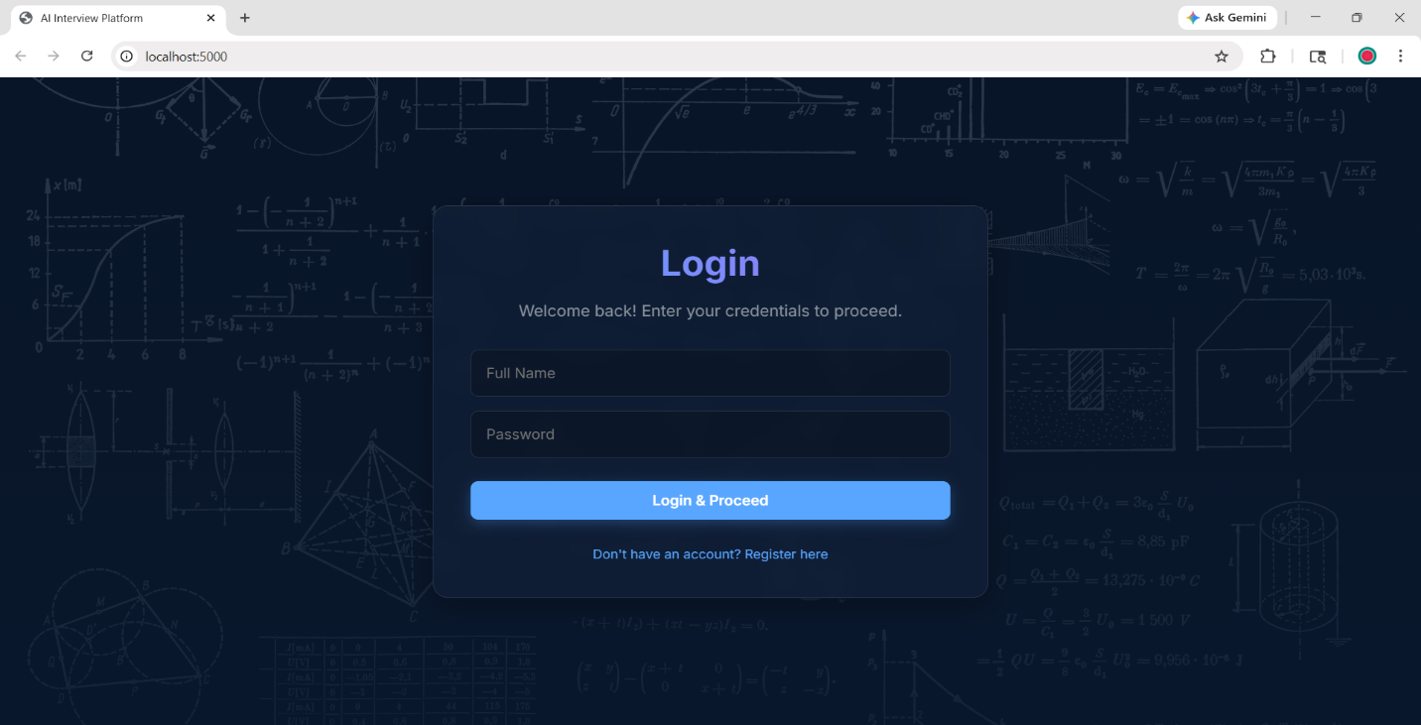

4.Start interview Page:
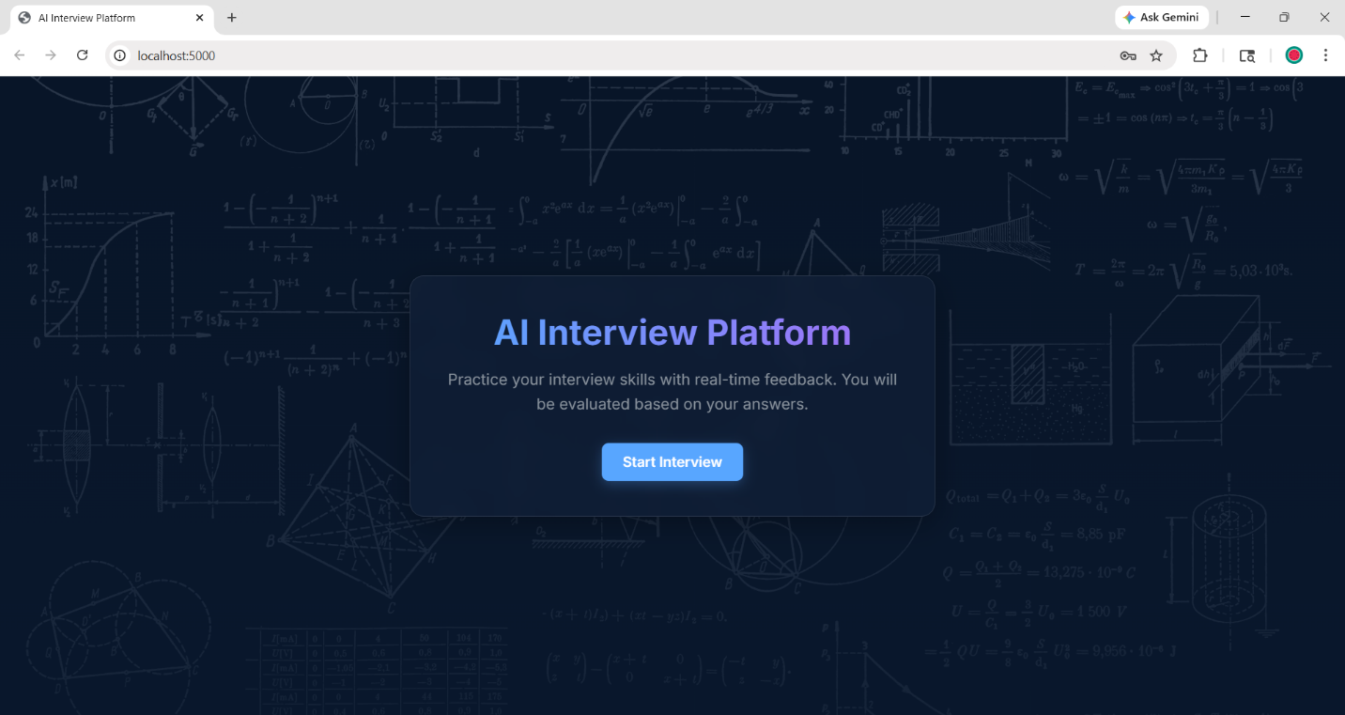

5.Video and Text Interview Page:
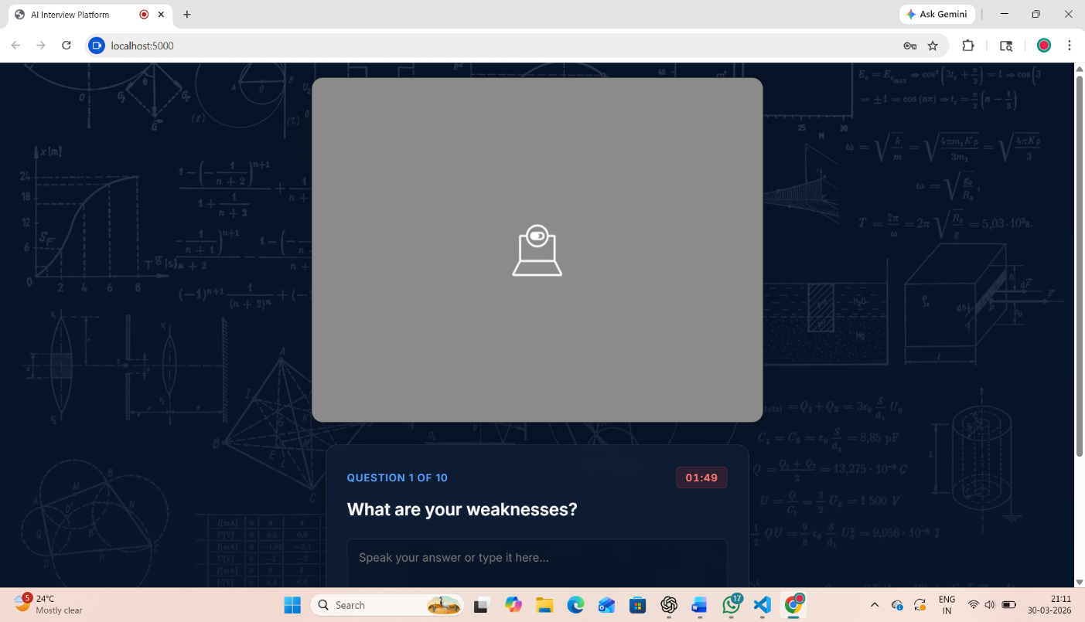

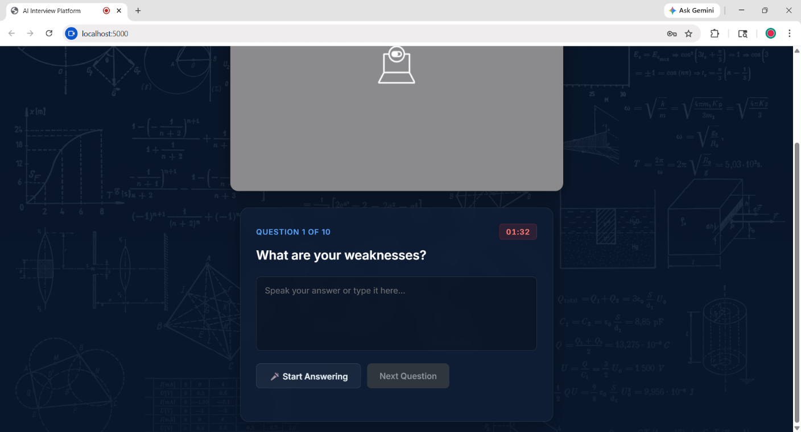
6.Questions:
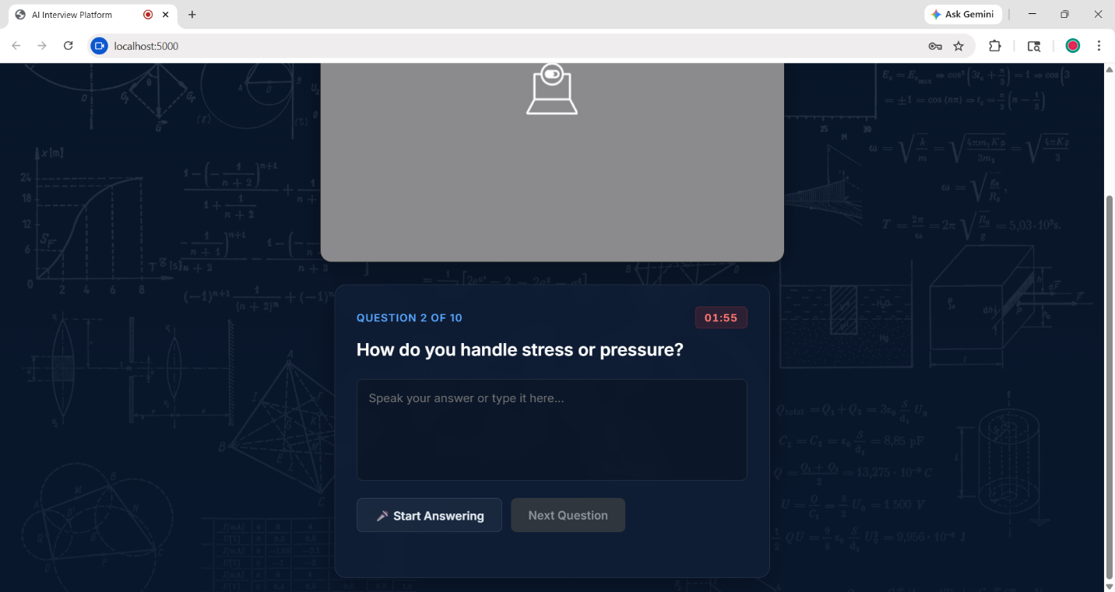

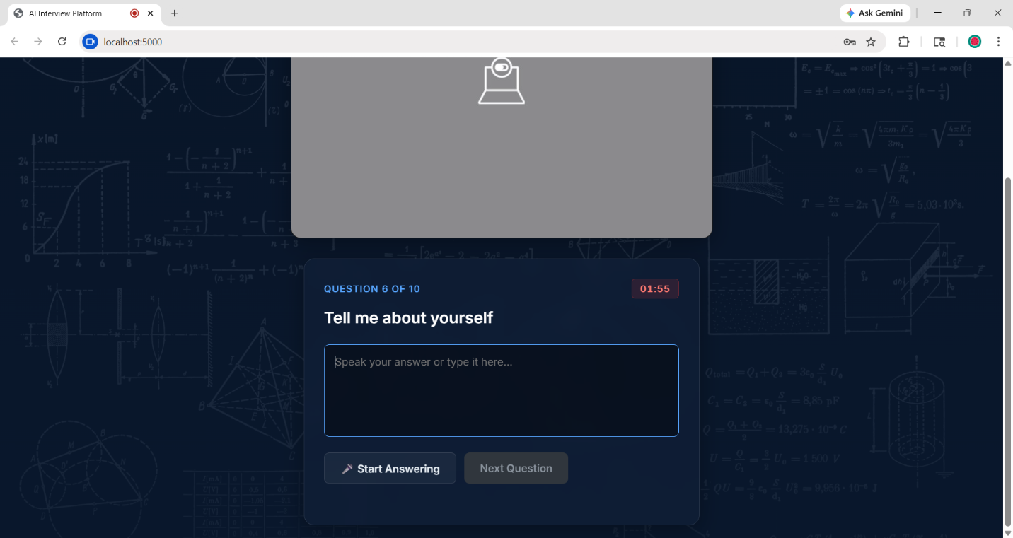

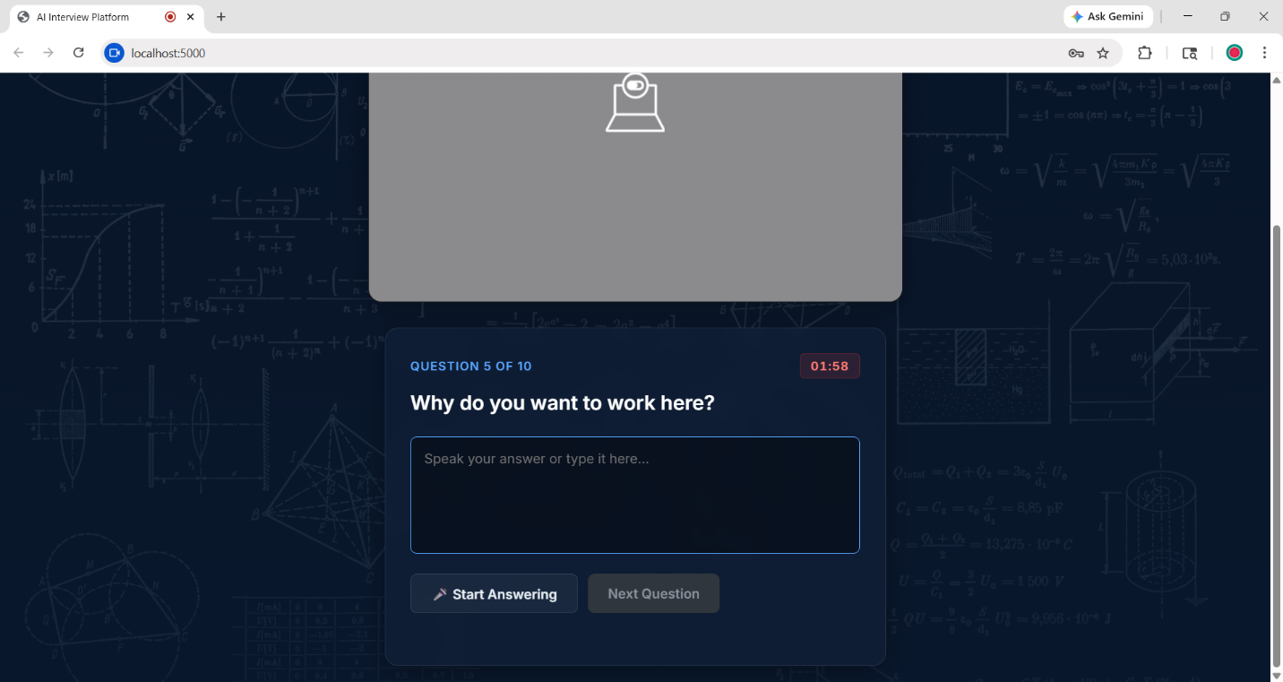

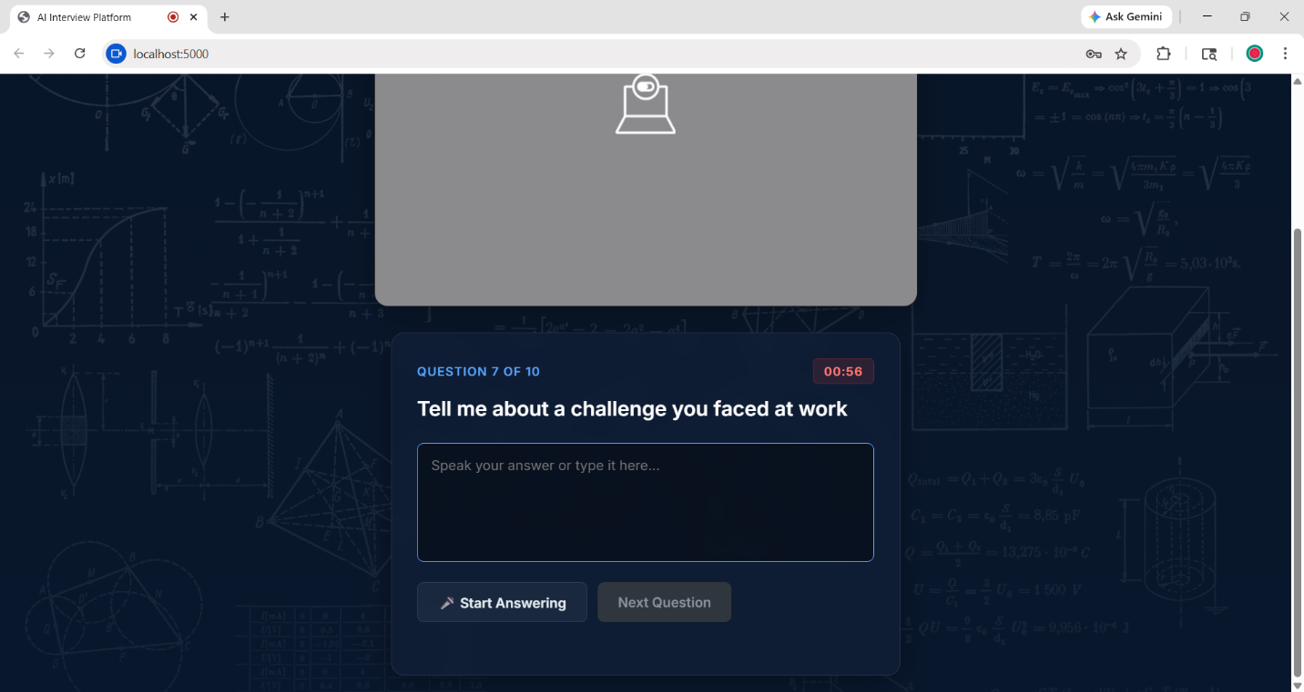

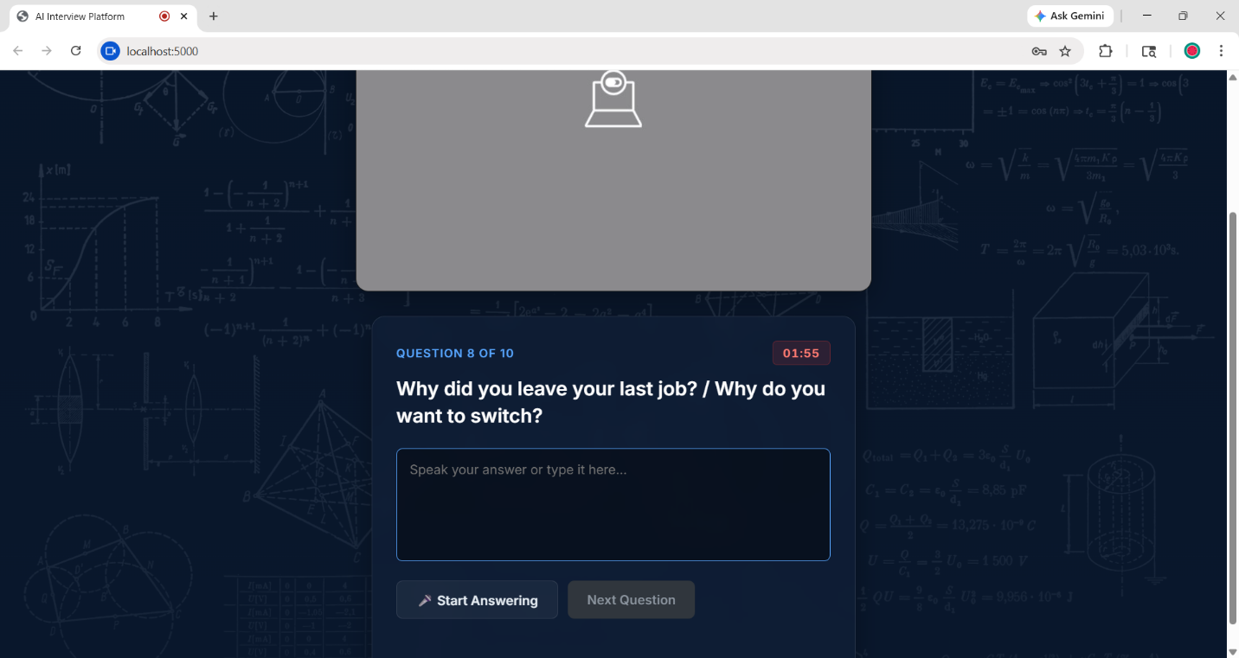
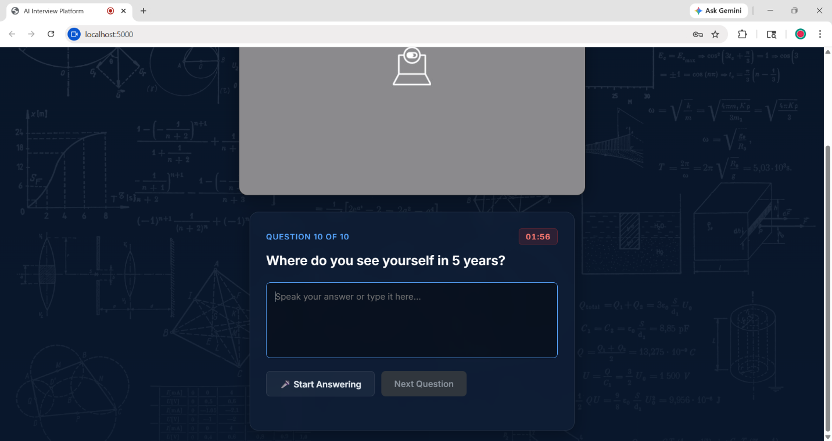
7.Report Page:

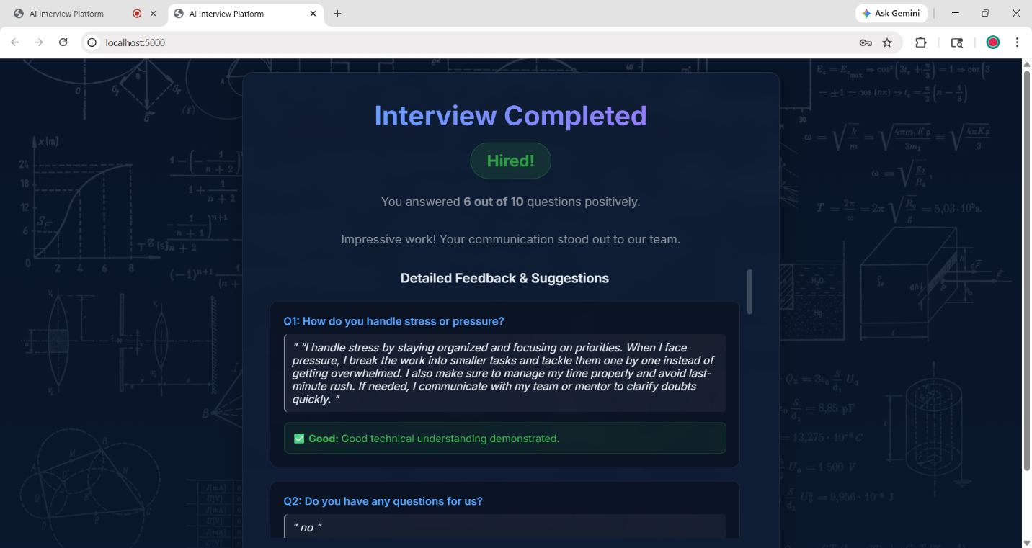

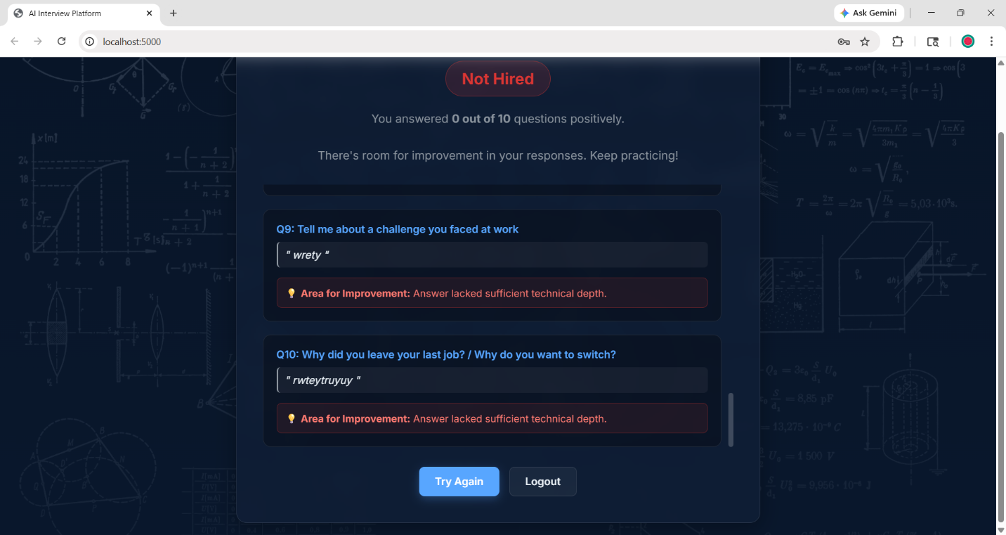

7.Logout Page:
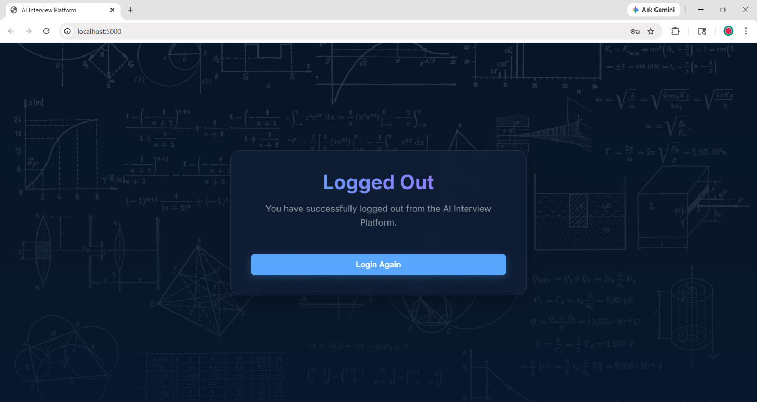

6. FUTURE SCOPE
1. Cloud Deployment
- Host the system on cloud platforms like:
  - AWS / Google Cloud / Azure
- Ensure:
  - High availability
  - Data security
  - Scalability

2. Mobile Application
- Develop an Android/iOS app for easy access.
- Users can attend interviews or manage bookings anytime.

3. Advanced Security Features
- Implement:
  - Data encryption
  - Secure login (OTP / 2FA)
  - Role-based access control

4. Face Expression Analysis
- Integrate facial recognition technology using AI.
- Analyze:
  - Nervousness
  - Eye contact
- Helps in evaluating non-verbal communication skills.
- Can generate behavioral score based on expressions.

5. Integration with Job Portals
- Connect with platforms like:
  - LinkedIn
  - Naukri
- Allow direct interview scheduling and candidate screening.

6. Chatbot Assistance
- Add AI chatbot to:
1.Guide users 2.Ask Queries

7.CONCLUSION

The developed system successfully achieves its objective of providing an efficient and structured platform for managing the interview process and evaluating candidate performance. It integrates key modules such as user management, interview scheduling, question handling, response recording, and report generation into a single system, ensuring smooth and organized operations.

This project simplifies the traditional interview process by digitizing all activities, reducing manual effort, and minimizing errors. The use of a relational database ensures data consistency, integrity, and easy retrieval of information. Each component of the system, including User, Interview, Question, Response, and Report, is properly designed and interconnected, which helps in maintaining a logical flow of data throughout the system.

One of the major advantages of this system is its ability to generate structured reports based on candidate responses. This helps in better decision-making and provides a clear understanding of candidate performance. The system is user-friendly and can be easily used by both administrators and users without requiring advanced technical knowledge.

Additionally, the project lays a strong foundation for future enhancements such as AI-based evaluation, video interview analysis, grammar checking, and facial expression recognition. These features can further improve the system by making it more intelligent and closer to real-world interview scenarios.

In conclusion, the system is reliable, scalable, and efficient, making it suitable for academic as well as practical applications. It not only demonstrates the effective use of database design and system modeling concepts but also highlights the potential of integrating modern technologies to enhance the overall functionality of interview management systems.

7.BIBLIOGRAPHY (REFERENCES AND BOOKS AND LINKS)

Books

Ramez Elmasri & Shamkant B. Navathe
Fundamentals of Database Systems
Pearson Education

Abraham Silberschatz, Henry F. Korth & S. Sudarshan
Database System Concepts
McGraw-Hill

Ian Sommerville
Software Engineering
Pearson

Herbert Schildt
Java: The Complete Reference
McGraw-Hill

Web References

W3Schools
https://www.w3schools.com/

GeeksforGeeks
https://www.geeksforgeeks.org/

TutorialsPoint
https://www.tutorialspoint.com/

MDN Web Docs
https://developer.mozilla.org/

Stack Overflow
https://stackoverflow.com/

Research / Concept References

Introduction to Database Systems and ER Modeling

Concepts of Relational Database Design

Basics of Artificial Intelligence and NLP

Web Development Technologies (HTML, CSS, JavaScript, Python/Java)

Tools & Technologies Used

Visual Studio Code (Code Editor)

HTML, CSS, JavaScript

Database mysql/ Json (Backend)

Web Browser (Google Chrome)

